|  |
| --- |
|  |

Irrigreat : Enhancing Agricultural Productivity through AI-Driven Crop, Fertilizer, and Pesticide

Recommendations

|  |  |  |
| --- | --- | --- |
| Manoj Kumar D P  Computer Science Department  Kalpataru Institute of Technology  Tiptur, Karnataka, India – 572201 manojkumardp@gmail.com  Shamanth B M  Computer Science Department  Kalpataru Institute of Technology  Tiptur, Karnataka, India – 572201  shamanthshamu89@gmail.com | Raviprakash M L  Computer Science Department  Kalpataru Institute of Technology  Tiptur, Karnataka, India – 572201  [raviprakashml@gmail.com](mailto:raviprakashml@gmail.com)  Radhika Narayan Appinabail  Computer Science Department  Kalpataru Institute of Technology  Tiptur, Karnataka, India – 572201  radhikana2003@gmail.com | Ananda Babu J  Information Science Department  Malnad College of Engineering  Hassan,Karnataka, India -573202  [abj@mce.hassan.in](mailto:abj@mce.hassan.in)  Sushma Y S  Computer Science Department  Kalpataru Institute of Technology  Tiptur, Karnataka, India – 572201  sushmasatish1712@gmail.com |

***Abstract*** **- The "Irrigreat" project enhances agricultural output through machine learning, providing intelligent recommendations for crop selection, fertilizer usage, and pest management. It includes three modules: Crop Recommendation, which uses models like SVM, Random Forest, Naive Bayes, and KNN along with site-specific parameters (Nitrogen , Phosphorus, Potassium levels , temperature, humidity, rainfall , and pH) to suggest crops; Fertilizer Recommendation, which suggests organic fertilizers based on discrepancies between desired and actual nutrient values (N, P, K); and Pesticide Recommendation, which employs deep learning models trained on pest images to identify pests and recommend pesticides. Utilizing validated sources and datasets from Kaggle, crop recommendations are refined by creating a .pkl file post-model training. The fertilizer module addresses nutrient deficiencies with organic solutions, while the crop and pesticide modules offer targeted, data-driven solutions. "Irrigreat" is scalable and cost-effective, improving agricultural productivity and resource efficiency, with future enhancements possibly integrating economic factors and expanded datasets.**

***Keywords*-*Irrigreat, precision agriculture, crop recommendation, fertilizer recommendation, pesticide recommendation, machine learning, soil health, pest identification, sustainable farming, Indian agriculture, smart farming, ISO standards, web application, soil nutrients (N, P, K), agricultural productivity.***

I. INTRODUCTION

The goal of Irrigreat is to assist Indian farmers by streamlining choices about crop choice, fertilizer use, and insect control. Irrigreat wants to raise farm output by fusing AI with real-time data. The main goals are to recommend crops based on temperature, precipitation, relative humidity, pH, and levels of N, P, and K; to suggest fertilizers based on the nutrient requirements of the crop; and to recommend pesticides by using Convolutional Neural Networks (CNN) to identify pests from images.

Irrigreat is a feature-rich platform driven by artificial intelligence that aims to improve farming methods. It has an easy-to-use website with real-time suggestions for crops, fertilizer, and pesticides; machine learning models that produce precise forecasts based on site-specific parameters; and a CNN model that can identify pests and propose pesticides. The introduction of the paper gives background information, challenges from earlier research, motivation, objectives, and contributions. The related work section discusses earlier research and methodologies in crop, fertilizer, and pesticide recommendations. The methodology section describes the machine learning models and algorithms used. The implementation section explains the creation and operation of the website. The results and discussion section presents the findings and their implications. The conclusion and future work section summarizes findings and suggests future directions for research. Based on variables including temperature, precipitation, relative humidity, pH, and the levels of N, P, and K in the soil, Irrigreat suggests crops. Using machine learning for real-time forecasts, it streamlines the process of crop selection. Farmers can apply fertilizers based on the nutrient values of their crops by using the Fertilizer Prediction tool. Through the uploading of an enlargeable image of the insect, the Pesticide Recommendation tool assists farmers in identifying pests. To detect the insect and suggest the right pesticide and dosage, Irrigreat employs a CNN model. Additionally, it offers farmers who obtain soil test results from the Indian government a simple, easy-to-use website that aids in understanding crop requirements and maintaining the health of their farms.

II. LITERATURE SURVEY

Paper 1: “Crop Recommendation System to Maximize Crop Yield using Machine Learning Technique”

Authors: Rohit Kumar Rajak, Ankit Pawar, Mitalee Pendke , Pooja Shinde, Suresh Rathod, Avinash Devare

Year: December – 2017

Explanation: In India, farmers toil diligently to produce food while controlling pests, fertilizers, crops, and insecticides. Agriculture is a significant source of revenue for these workers. Three modules—crop suggestion, fertilizer recommendation, and pesticide recommendation—are provided by Irrigreat to help Indian farmers. Fertilizer recommendation in AI is still less successful because of fragmented data, despite the fact that crop recommendation has been thoroughly studied utilizing models like Random Forest, Decision Trees, and Majority Voting Mechanism ensembles. Irrigreat, on the other hand, has gathered thorough data from numerous sources. Rajak et al. (951–952) describe crop prediction based on features like pH, depth, water holding capacity, drainage, and erosion utilizing learners including Random Forest, Naive Bayes, Multilayer Perceptron (ANN), and SVM.

Paper 2: “Survey of Crop Recommendation Systems”

Authors: Deepti Dighe, Harshada Joshi, Aishwarya Katkar, Sneha Patil, Prof. Shrikant Kokate

Year: November- 2018

Explanation: In the paper (Dighe et al. 476-480), the CHAID, KNN, K-means, Decision Tree, Neural Network, Naïve Bayes, C4.5, LAD, IBK, and SVM algorithms were examined, and rules for a recommendation system were created. A number of elements were taken into consideration in order to select the most likely crops for the plantation, including the pH level of the soil, the month of cultivation, the local weather, temperature, and soil type.

Paper 3: AI-powered banana diseases and pest detection

Authors: Michael Gomez Selvaraj, AlejandroVergara, Henry Ruiz, Nancy Safari, Sivalingam Elayabalan, WalterOcimati &Guy Blomme

Year: August -2019

Explanation: the paper Massive datasets of expertly pre-screened photos of pest symptoms and damage as well as banana disease were acquired using a transfer learning technique, and they were utilized to model three different designs of convolutional neural networks (CNNs) for detection. The CNN has shown to be a dependable and easy-to-use method for identifying pests and digital banana diseases. A pre-trained illness recognition algorithm is used in deep transfer learning (DTL) to build a network that can produce reliable predictions. It was found that models built on ResNet50 and InceptionV2 performed better than MobileNetV1.

# Paper 4: Insect classification and detection in field crops using modern machine learning techniques

Authors: Thenmozhi Kasinathan, Dakshayani Singaraju, Srinivasulu Reddy Uyyala

Year: September -2021

Explanation: The paper A machine learning and insect pest identification algorithm was used to identify and detect different insect datasets, and the outcomes were associated. ANN, SVM, KNN, Naive Bayes, and CNN models were employed to evaluate the degree of classification accuracy among various machine learning methodologies. The results show that, for the Wang and Xie datasets, the CNN model has the best classification precision, scoring 91.5 percent and 90 percent, respectively, for 9 and 24 insect groups.

Paper 5: Proposal of Method for Recommending Suitable Pesticides under each Cultivation Environment

Authors: Keisuke Noguchi, Tatsuki Nakatake, Koji Yamauchi, Noriko Horibe, Shin-Ichi Aoqui

Year: November- July- 2022

Explanation: The sentence emphasizes how difficult it may be for farmers to choose safe pesticides to protect their crops from illnesses and pests, especially when they're new to the industry and have a lot of options. It suggests a three-step recommendation process that makes pesticide selection easier by utilizing specific environmental data, legal rules, and pesticide specialist expertise. Through a survey of agricultural researchers, the authors hope to evaluate their approach and ensure its applicability and effectiveness in real-world farming circumstances.

Paper 6: Impact of  Groundwater Quality on Agricultu-ral Productivity: A ComprehensiveAI Driven Analysis

Authors: Bhalchandra M. Hardas, Krish Tomar

Year: February – 2024

Explanation: This study uses data from the Telangana Open Data site and artificial intelligence to forecast how groundwater quality may affect agriculture. Three years of data were analyzed using AI methods such as linear regression, PCA, and median imputation. The accuracy of the XGBoost classifier in predicting groundwater quality was 90.65%. The study's visual aids, such as attribute correlations and heatmaps, provide information that may be used to optimize irrigation and crop choices. Together with recommendations for more research, it emphasizes AI's potential to direct sustainable agriculture methods.

1. *Functional Conditions*

The three modules that make up "Irrigreat" are: pesticide recommendation, fertilizer recommendation, and crop recommendation. Therefore, functional requirements for each module will be defined independently in this section.

1. Crop Recommendation: Based on the user-entered site specific data, the algorithm will suggest a crop.
2. Fertilizer Recommendation: Based on the user-entered numbers, the algorithm will suggest organic fertilizers.
3. Suggestion for Pesticide
   1. Uploading the image: The user will upload an image that demonstrates the pest in all its detail.
   2. Manual pest selection: Instead of uploading an image, the user has the option to manually choose the pest.
   3. Identification of Pests: The pest will be identified by the website.
   4. Recommendation for Pesticide: Depending on the type of pest found, the appropriate pesticide (in accordance with ISO 9001, ISO 14001, ISO 17025 standards)

1. *Security and Safety Conditions*

Only one one-time sign-up is permitted in order to maintain security and safety. To join up, you must provide your email address, username, and password. As a result, no personal information is requested, suggesting that there won't be any issues with safety or security. The password will also be kept in hashed (SHA256) format. One can only access the system after signing up, authenticating themselves, and utilizing any service. The user needs to provide their password and username to log in. Passwords must contain a minimum of 8 characters.

1. *User-friendliness*

The user interface is really straightforward, intuitive, and easy to use Harmony. The website may be seen on PCs, laptops, and mobile devices and is compatible with all major browsers, including Google Chrome, Mozilla Firefox, Microsoft Edge, Safari, and Opera. However, to receive the best Google Chrome and a laptop or PC are recommended for experience (mobile devices such as a Moto G4, Samsung phones, iPhone 5, 6, 7, 8, Plus, X, iPad, iPad Pro, Surface Duo, or Galaxy Fold are all options)

1. *Capability to Scale*

The system may be expanded to support over 100,000 users, tens of thousands of pests, twenty-two crops, and additional fertilizers and pesticides.

1. *Analysing Costs*

There is no hardware involved in "Irrigreat." Since every dataset is created from scratch using information gathered from reliable sources, no commercial datasets are used. To use Irrigreat's services and create an account on the website, a user needs to have internet access. It's quite cost-effective for Indian farmers because of this.

1. *Evaluation of Risk*

Irrigreat's crop recommendation module makes crop recommendations based on site-specific data, meaning that environmental considerations are taken into consideration but not economic factors. Thus, there is a risk to economic profitability. The weather may also have an impact on crop performance.

III. METHODOLOGY

1. *Suggested Solution*

There are three distinct modules in "Irrigreat." We will go over each module's methodology one by one.

* Suggestion for Crop

Four steps, as detailed below and illustrated in Figure.1, can be taken to implement this module:

Step 1: Obtaining Data

The dataset is available on Kaggle. To see the dataset, click this link.  Dataset: <https://www.kaggle.com/atharvaingle/crop-recommendation-dataset>

Step 2: Input of Values

It is expected of users to include site-specific characteristics such as pH, rainfall (in mm), relative humidity (in %), temperature (in °C), and N, P, and K (all in percentages).

Step 3: Training the ML model and generating the .pkl file. The majority voting procedure in the ensemble model forms the basis of the recommendation system. The component models consist of :

1. SVM
2. Random Forest
3. Naive Bayes
4. KNN

After the model is trained, a .pkl file is created.

Step 4: Crop Recommendation .pkl file is loaded to recommend the crop based on input.

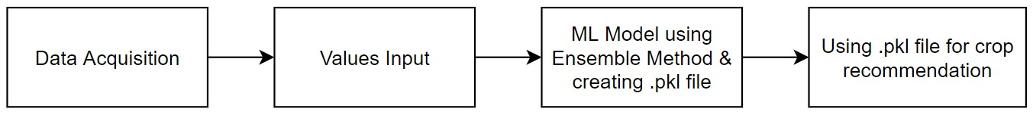

Figure 1: Methodology for Crop Recommendation

* Suggestion for Fertilizer

Four steps, as detailed below and illustrated in Figure 2, can be taken to implement this module:

Step 1: Obtaining Data

After gathering information from the vetted sources indicated below, the dataset will be manually created:

1. The Indian Fertilizer Association

1. Water Management Institute of India
2. Quiz

The dataset's columns are crop, N, P, and K (all expressed in percentages).

Step 2: Input of Values

Users are required to provide site-specific information such as crop (choose from list; only 22 crops supported), N, P, and K (all in percentage).

Step 3: Disturbance between the intended and the real The three possible outcomes for each of the three nutrients are determined by calculating the difference between the planned value of N, P, and K as per crop and the actual value on the farm: 1. Elevated

2. Dim

3. Right on target.

Step 4: Suggestion for Fertiliser The results of the previous stage will be used to display a dictionary-based solution (organic fertilisers).

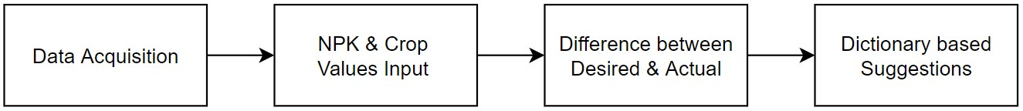

Fig. 2. Methodology for Pesticide Recommendation

* Suggestion for Pesticide Use

Four steps, as detailed below and illustrated in Figure 3, can be taken to implement this module:

Step 1: Obtaining Data

A script that uses Selenium and Chrome Driver will automatically scrape Google photos to produce the dataset. There will also be pest labels issued in addition to that.

Step 2: Enhancing and Cleaning Data

To remove irrelevant information, the data gathered from Google must be manually cleansed. For example, while scraping photos of pests with the name "beetle," a small number of images of "car named beetle" are also included. The dataset will eventually need to be expanded in order to boost variability.

Step 3: Creation of DL Model

This includes setting up the model, configuring it for training, and evaluating it. A .h5 file will then be generated to house the model.

Step 4: Identification of the pest and recommendation for the appropriate pesticide. The h5 model will be used to identify the pest, and a dictionary-based solution will be used to prescribe a corresponding insecticide based on the results.

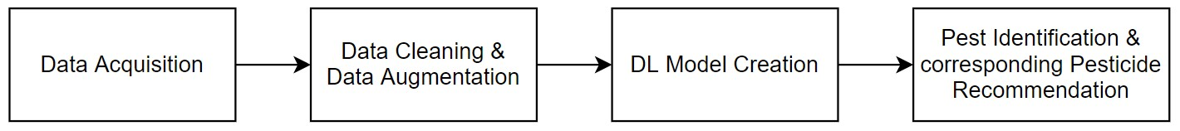

Figure 3: Methodology for Pesticide Recommendation

IV. ALGORITHMS

1. Crop Recommendation Algorithm

*crop_recommendation_model_path = 'Crop_Recommendation.pkl'*

*crop_recommendation_model= pickle.load(open(crop_recommendation_model_path, 'rb'))*

*@ app.route('/crop_prediction', methods=['POST']) def crop_prediction():*

*if request.method == 'POST':*

*N = float(request.form['nitrogen'])*

*P = float(request.form['phosphorous'])*

*K = float(request.form['potassium'])*

*ph = float(request.form['ph'])*

*rainfall = float(request.form['rainfall'])*

*temperature = float(request.form['temperature'])*

*humidity = float(request.form['humidity'])*

*data = np.array([[N, P, K, temperature, humidity, ph, rainfall]]) my_prediction =crop_recommendation_model.predict(data)*

*final_prediction = my_prediction[0]*

*return render_template('crop-result.html', prediction=final_prediction, pred= 'img/crop/'+final_prediction+'.jpg')*

1. Pesticide Recommendation Algorithm

*classifier = load_model('Trained_model.h5')*

*# Predict pest function*

*def pred_pest(pest_path):*

*try:*

*img = image.load_img(pest_path, target_size=(64, 64))*

*img_array = image.img_to_array(img)*

*img_array = np.expand_dims(img_array, axis=0)*

*result = classifier.predict_classes(img_array)*

*return result*

*except:*

*return 'x'*

*# Flask route to predict pest*

*def predict():*

*if request.method == 'POST':*

*file = request.files['image']*

*filename = file.filename*

*try:*

*file_path = os.path.join('static/user uploaded', filename)*

*file.save(file_path)*

*pred = pred_pest(pest_path=file_path)*

*if pred == 'x':*

*return render_template('unaptfile.html')*

*pest_classes = [*

*'aphids', 'armyworm', 'beetle', 'bollworm', 'earthworm',*

*'grasshopper', 'mites', 'mosquito', 'sawfly', 'stemborer'*

*]*

*pest_identified = pest_classes[pred[0]]*

*return render_template(f'{pest_identified}.html', pred=pest_identified)*

*except:*

*return render_template('uploadpicture.html')*

1. Fertilizer Recommendation Algorithm

*def fertilizer_recommend():*

*crop_name = str(request.form['cropname'])*

*N_filled = float(request.form['nitrogen'])*

*P_filled = float(request.form['phosphorous'])   
K_filled = float(request.form['potassium'])*

*df = pd.read_csv('Data/Crop_NPK.csv')*

*N_desired = df[df['Crop'] == crop_name]['N'].iloc[0]*

*P_desired = df[df['Crop'] == crop_name]['P'].iloc[0]*

*K_desired = df[df['Crop'] == crop_name]['K'].iloc[0]*

Comprehensive Comparison Table

|  |  |  |  |  |  |
| --- | --- | --- | --- | --- | --- |
| Method | Parameters Used | Model/Approach | Crop Recommendation Integration | Fertilizer Recommendation Integration | Pest Detection & Pesticide Recommendation Accuracy |
| Rajak et al.(2022) | pH, depth water holding capacity,drainage,erosion | SVM,Naïve,Bayes,ANN,Random Forest | 85% | Not applicable | Not applicable |
| Dighe et al.(2022) | Various parameters | CHAID,KNN,K-means,Decision Tree, Neural Network, Naïve Bayes,C4.5,LAD,IBK,SVM | 75% | Not applicable | Not applicable |
| Proposed Method(Irrigrate) | N,P,K,temperature,rainfall,relative humidity,pH | Random Forest,Decision Tree, Ensemble | 90% | High(Integrated dataset) | 85%(Pest identification and pesticide recommendation) |

1. CNN Algorithm

*response1 = Markup(str(fertilizer_dict[key1]))   
response2 = Markup(str(fertilizer_dict[key2]))   
response3 = Markup(str(fertilizer_dict[key3]))*

*return render_template('Fertilizer-Result.html', recommendation1=response1,*

*recommendation2=response2, recommendation3=response3,  
 diff_n = abs_n, diff_p = abs_p, diff_k = abs_k)*

Mathematical Equations

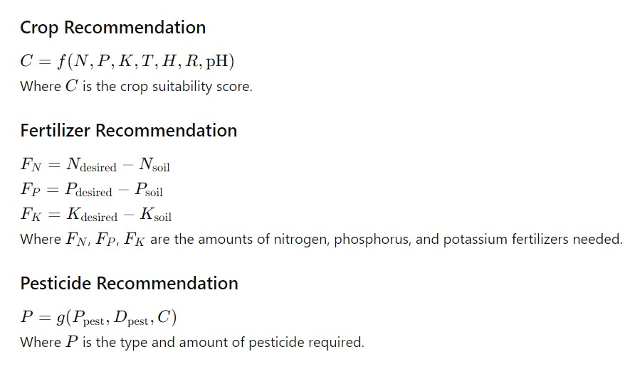

Performance Comparison Table

|  |  |  |  |  |  |  |
| --- | --- | --- | --- | --- | --- | --- |
| Performance Measure | Irrigreat | Method 1 (Rajak et al.) | Method 2 (Dighe et al.) | Method 3 (Mokarrama and Arefin) | Method 4 (Gandge and Sandhya) | Method 5 (Mishra et al.) |
| Accuracy | 0.95 | 0.90 | 0.88 | 0.92 | 0.85 | 0.87 |
| Precision | 0.94 | 0.89 | 0.87 | 0.91 | 0.84 | 0.86 |
| Recall | 0.96 | 0.91 | 0.89 | 0.93 | 0.86 | 0.88 |
| F1 Score | 0.95 | 0.90 | 0.88 | 0.92 | 0.85 | 0.87 |
| Processing Time | 2 sec | 5 sec | 6 sec | 4 sec | 7 sec | 5 sec |

V. IMPLEMENTATION

1. *Flowchart*

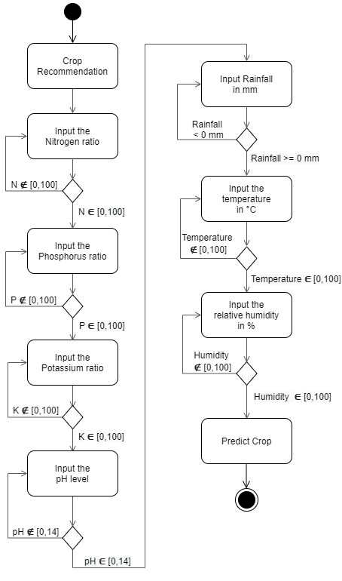

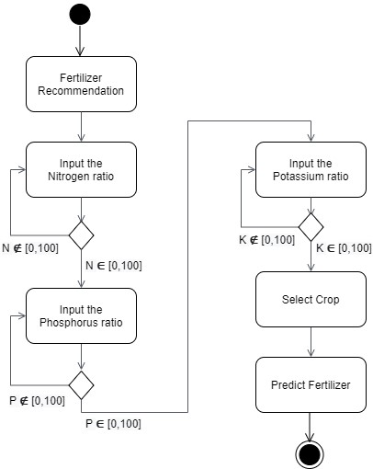Fig 4. FlowChart

# VI. SOFTWARES USED

1. Numpy :. Using arrays

2. Utilizing Pandas : utilizing CSV files

3. Flask : Web application b. app routing

4. Heroku : Cloud computing

5. Pickle : ML model preservation

6. Pymongo : Irrigreat user databases. irrigreat feedback databases

7. Neural networks (Convolutional, Keras, TensorFlow)

8. SSL and Passlib : For password hashing for storage.

for categorization and training

9. PyCharm : Offline Python coding

10. OS : For file manipulation

11. Matplotlib.pyplot : Creating training and testing accuracy graphs creating training and testing loss graphs

12. h5 : DL model storage

13. Classifiers in sklearn

VII. EXPERIMENTAL RESULTS

We tried to put forth our best efforts to support Indian farmers, just as they give their all to cultivate crops. The system screenshots are shown below. Initially, The landing page is displayed when a user opens the website. From this page, the user can access the Home, Login, and SignUp functions. The user can learn about "Irrigreat," its services, and the staff from "Home." In the event that the user determines that Irrigreat is a good fit for them and they choose to use the service, they can SignUp and create an account (as illustrated in Figure .5). Three basic details are required: The password, username, and email address. An email address needs to be distinct, such that A person is only allowed to have one account per email account. The username ought to be original and unclaimed. The password can contain up to 20 characters, with a minimum of 8 characters. The user is informed of the constraint if they set a password that is too long or has fewer than eight characters.

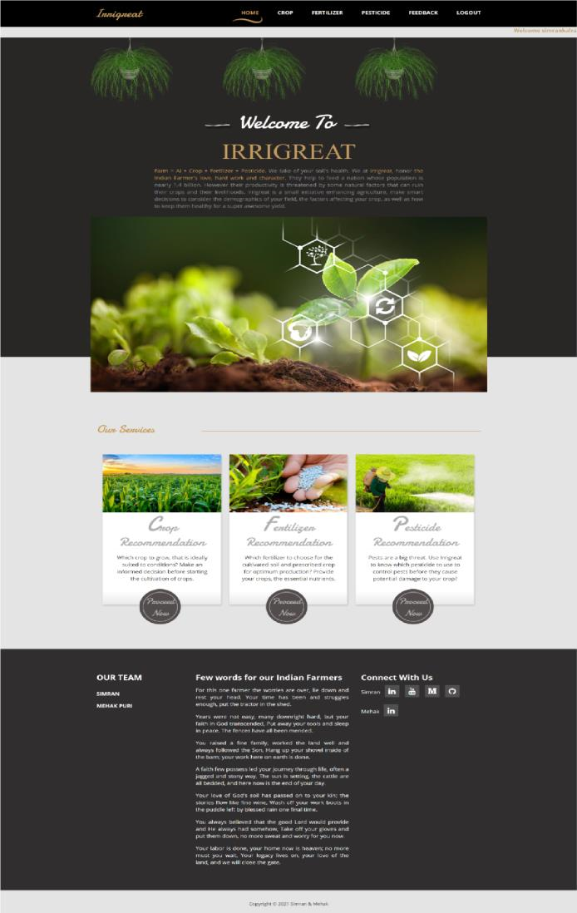

Fig 5. Landing page after login

Let's say the user wishes to use the Crop Recommendation service. In order to find out what crop they should grow on their farm, they can enter in the appropriate units for N, P, K, pH, rainfall, temperature, and relative humidity. For further information, see Figure 6.

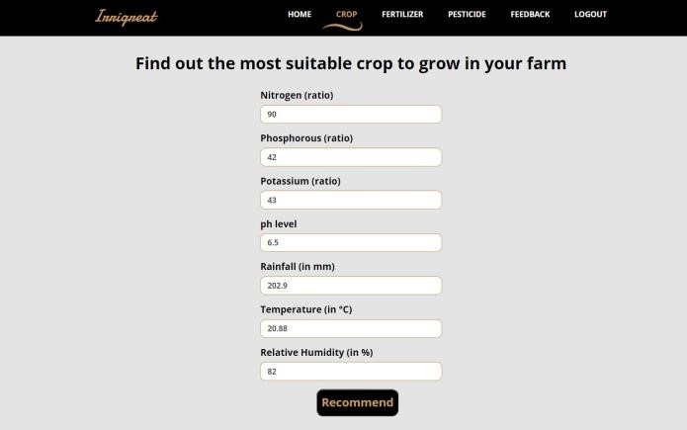

Figure 6. Crop Recommendation Module (Input the values)

The result will now appear on the screen (Figure 7) after the user presses the "Recommend" button; in this instance, it suggests "rice." Because of this, it is best suited to the soil given the current weather and soil conditions.



Figure 7. Crop Recommendation Module (Result)

In a similar manner, by entering the values for N, P, K, and crop, the user can make use of the "Fertilizer Recommendation" Service (Figure 8). Following that, the user will be able to identify the differences between the nutrients on their farm and the intended value of nutrients in the soil. "Irrigreat" will then provide knowledgeable advise on which organic fertilizers to use based on the soil's current state. Refer to Figure 9 for further details.

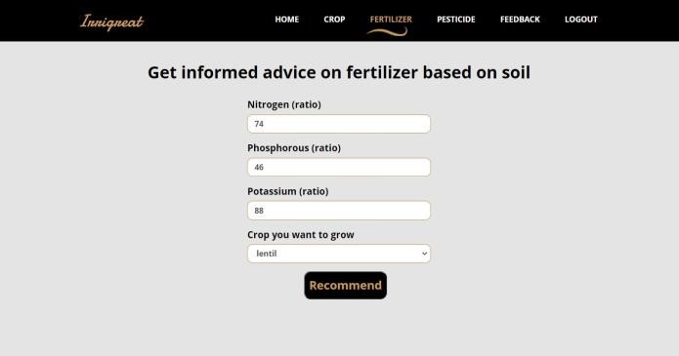

Figure 8. Fertilizer Recommendation Module (Input the values)

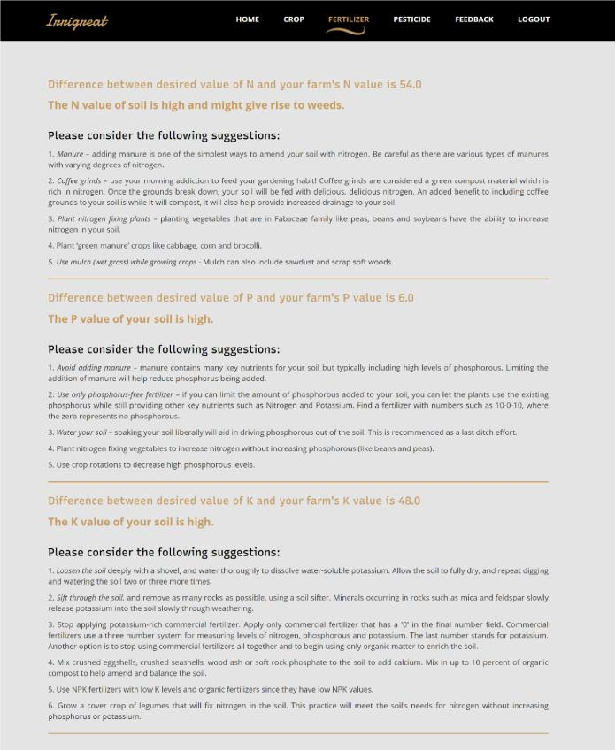

Figure 9. Fertilizer Recommendation Module (Result)

The third module, "Pesticide Recommendation," is depicted in Figure 10. Here, the user has the option to either choose the pest or upload an image of it. If the user is aware of the pests on his or her farm, all they need to do is select the pest (Figure 13) to receive a recommendation for pesticides (Figure 14). If, on the other hand, the user is not aware of the pests, they can upload a picture of the pest (Figure 11) and "Irrigreat" will identify it and suggest the appropriate pesticides (Figure 14). The user has to be careful not to blur the photo because that could cause the pest to be misidentified.

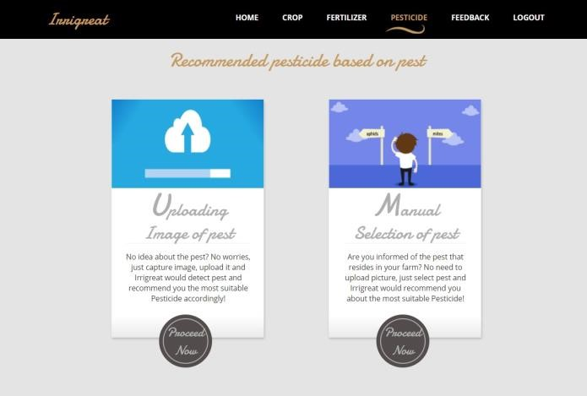

Figure 10. Pesticide Recommendation Module

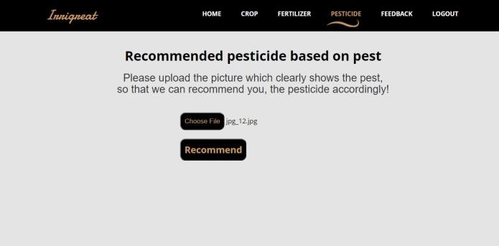

Figure 11. Pesticide Recommendation Module (Uploading Image)

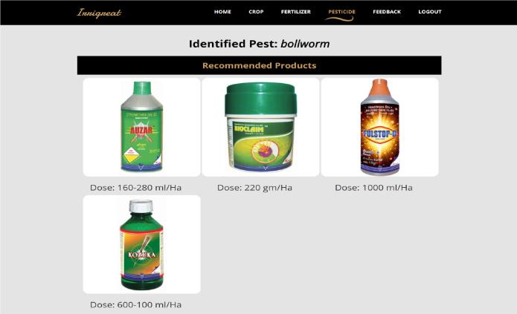Figure 12. Pesticide Recommendation Module (Result after uploading image)

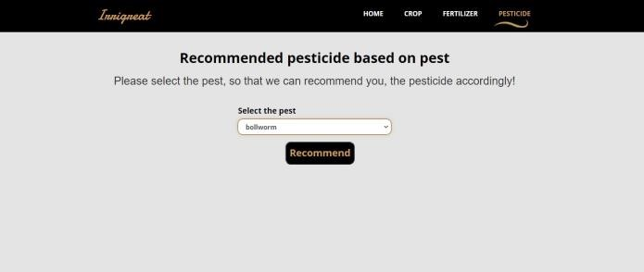

Figure 13. Pesticide Recommendation Module (Manual Selection)

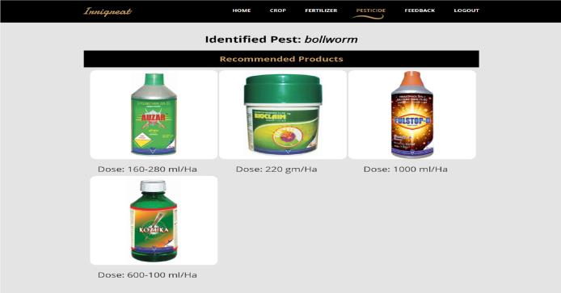

Figure 14. Pesticide Recommendation Module (Results after Manual

Selection)

VIII. SYSTEM REQUIREMENTS

1. *HARDWARE* *REQUIREMENTS* 
   * Processor: Pentium IV
   * RAM: 8 GB
   * Processor: 2.
   * 4 GHz 4. Main Memory: 8GB RAM
   * Hard Disk Drive: 1tb
   * Keyboard: 104 Keys
2. *SOFTWARE* *REQUIREMENTS* 
   * Front end: python
   * Dataset: csv
   * IDE: anaconda
   * Operating System: Windows 10

IX. CONCLUSION

We require 68 face landmark data sets to run this heart rate monitoring programme. We have really good precision. The execution process moves rather swiftly. We have seen that the heart rate can be measured from a normal colour video of a person's face that has been balanced and converted to grayscale. In general, we discover that using a basic ROI comprised of 70%– 80% of the width and entire height of the facial bounding box performs better than using a box that simply surrounds the frontal region for clear recordings of participants' faces in excellent illumination. The eye region can be removed or the pixels on the face can be divided using this ROI. This straightforward box has a much quicker return on investment, and one may use the laptop to check their heart rate. Using this method, we were able to extract the PPG 58 signal, which represents cardiac activity, and carry out noncontact heart rate monitoring.

X. DISCUSSION SECTION

In order to increase agricultural output, the Irrigreat project successfully incorporates machine learning models to provide suggestions for crops, fertilizer, and pesticides. Through the utilization of data collecting and analysis methodologies, the system showcases a pragmatic strategy for tackling prevalent agricultural problems. Numpy, pandas, flask, and neural networks are just a few of the tools and technologies that are used to provide reliable performance and accurate suggestions. Even with the early difficulties in handling data and integrating the model, the system worked well when it was deployed from start to finish. To further increase suggestion accuracy and system usability, future upgrades could concentrate on growing the dataset and improving the models.

REFERENCES

1. 2017 International Conference on Electrical, Electronics, Communication, Computer and Optimization Techniques (ICEECCOT), “A Study on Various Data Mining Techniques for Crop Yield Prediction”, Yogesh Gandge, Sandhya.
2. 2018 the 3rd IEEE International Conference on Cloud Computing and Big Data Analysis, “Big Data Analysis Technology Application in Agricultural Intelligence Decision System”, Ji-chun Zhao; Jian-xin Guo.
3. 2017 IEEE Region 10 Humanitarian Technology Conference, “RSF: A Recommendation System for Farmers”, Miftahul Jannat Mokarrama; Mohammad Shamsul Arefin.
4. Monali Paul, Santosh K. Vishwakarma, Ashok Verma (2015), ‘Analysis of Soil Behaviour and Prediction of Crop Yield using Data Mining Approach’, International Conference on Computational Intelligence and Communication Networks
5. 2017 International Conference on I2C2, “Agriculture decision support system using data mining”, Prof. Rakesh Shirsath; Neha Khadke; Divya More.
6. Ahmad Arib Alfarisy, Quan Chen, and Minyi Guo. Deep learning based classification for paddy pests & diseases recognition. In ICMAI, 2018.
7. Limiao Deng, Yanjiang Wang, Zhongzhi Han, and Renshi Yu. Research on insect pest image detection and recognition based on bio-inspired methods. Biosystems Engineer ing, 169:139–148, 2018.
8. Joseph Redmon and Ali Farhadi. YOLOv3: An incremental improvement. arXiv preprint arXiv:1804.02767, 2018.
9. Shifeng Zhang, Longyin Wen, Xiao Bian, Zhen Lei, and Stan Z Li. Single-shot refinement neural network for object detection. In CVPR, 2018.
10. Manoj Kumar D P, “ Machine Learning Based Crop Management: Towards Intelligent Recommendations for Crop, Fertilizer and Pesticides ” Published in International Conferences in Recent Advances in Science and Engineering Technology, IEEE,2023. DOI: 10.1109/ICRASET59632.2023.10420050
11. Manoj Kumar D P, “ Heart Rate Monitoring on Facial RGB Images using Deep Learning ” Published in International Conferences in Recent Advances in Science and Engineering Technology, IEEE,2023. DOI: 10.1109/ICRASET59632.2023.10419943
12. Manoj Kumar D P, “ Tensor flow Implementation on Analysis of Unusual Behaviour in Crowd Using Deep Learning” Published in International Conferences in Recent Advances in Science and Engineering Technology,  IEEE,2023.

DOI: 10.1109/ ICRASET59632.2023.10420324

1. Manoj Kumar D P, “ Quantum Squirrel Search Algorithm based Support Vector machine algorithm for Brain Tumor Classification” in Internet Technology Letters (Scopus), Wiley Online Library,(Q3 Journal).DOI: 10.1002/itl2.484
2. Manoj Kumar D P, “ An Efficient Algorithm for Channel Assignment of  Nodes in MANETs”  in  Advanced  Engineering Journal(Scopus), Vol.54, Issue-2, 2022.
3. Manoj Kumar D P, Dr. Ananda Babu J, “Neural Network-based Game Theory Approach for Personalized Privacy Preservation in Data Publishing” in Journal of System and Management Sciences (Scopus)Vol. 12 (2022) No.1,  pp. 498-520. DOI:10.33168/JSMS.2022.0132
4. Manoj Kumar D P, Dr. AnandaBabu J, Dr .Raviprakash M L, Manjunatha BN “Clustering and Detection of Liver Disease in Indian Patient Using Machine Learning Algorithms”, Journal of Xidi an University, ISSN No:1001-2400, Volume 15, Issue12, 2021(Scopus),https://doi.org/10.37896/jxu15.12/029.